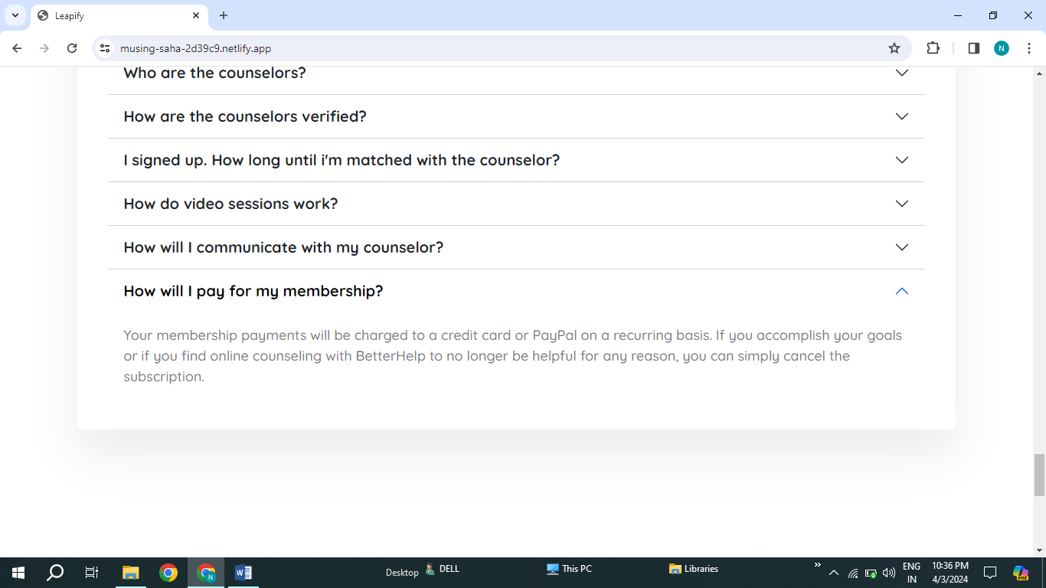

1. There is spelling mistake is payPal , it should be Paytm.
2. BetterHelp it is spelling mistake. Grammatical mistake.